**Hiring Process Analytics**

**Project Description**

This project involves analysis of a hiring process in company. It’s very crucial part of the company which helps in hiring talented people on a price where is benefited.

**Approach**

As per the given task we need to analyse the series of data provided

1. **Hiring Analysis:** The hiring process involves bringing new individuals into the organization for various roles.

Ans:

|  |  |
| --- | --- |
| **Male Hired** | **Female Hired** |
| 2563 | 1856 |
|  |  |

We can see that number of male employee is higher than female employee.

1. **Salary Analysis:**  Average salary is calculated by adding up the salaries of a group of employees and then dividing the total by the number of employees.

Ans:

|  |
| --- |
| **Average Salary** |
| 49983.02902 |

1. **Salary Distribution:** Class intervals represent ranges of values, in this case, salary ranges. The class interval is the difference between the upper and lower limits of a class.

Ans: We need to find the Minimum and Maximum salary:

|  |  |
| --- | --- |
| Min Salary | Max Salary |
| 100 | 400000 |

Now using index and match function we can divide the interval:

=INDEX(H:H, MATCH(G2, {100, 11000, 21000, 31000, 41000, 51000, 61000, 71000, 81000, 91000, 101000, 111000, 121000, 131000, 141000, 151000, 161000, 171000, 181000, 191000, 201000, 211000, 221000, 231000, 241000, 251000, 261000, 271000, 281000, 291000, 301000, 311000, 321000, 331000, 341000, 351000, 361000, 371000, 381000, 391000, 400001}, 1))

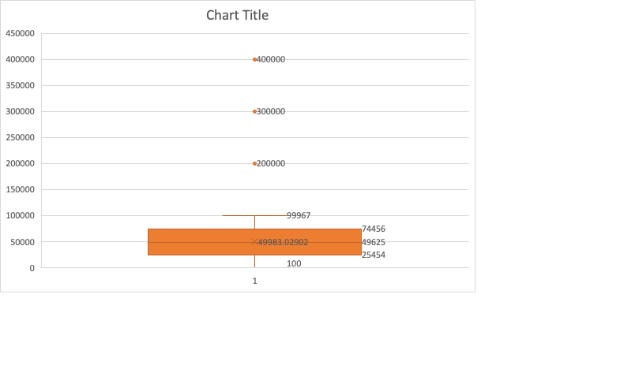

In the above given chart we can see that

From here we can see that there is huge difference between the lowest and highest salary offered.

1. **Departmental Analysis:** Visualizing data through charts and plots is a crucial part of data analysis.

Ans: To Get the count of each department we need to Pivot the table .

|  |  |
| --- | --- |
| **Row Labels** | **Count of Department** |
| Finance Department | 288 |
| General Management | 172 |
| Human Resource Department | 97 |
| Marketing Department | 325 |
| Operations Department | 2771 |
| Production Department | 380 |
| Purchase Department | 333 |
| Sales Department | 747 |
| Service Department | 2055 |
| Grand Total | 7168 |

**Operation department** has the highest number of employees and the **HR department** has lowest number of employees

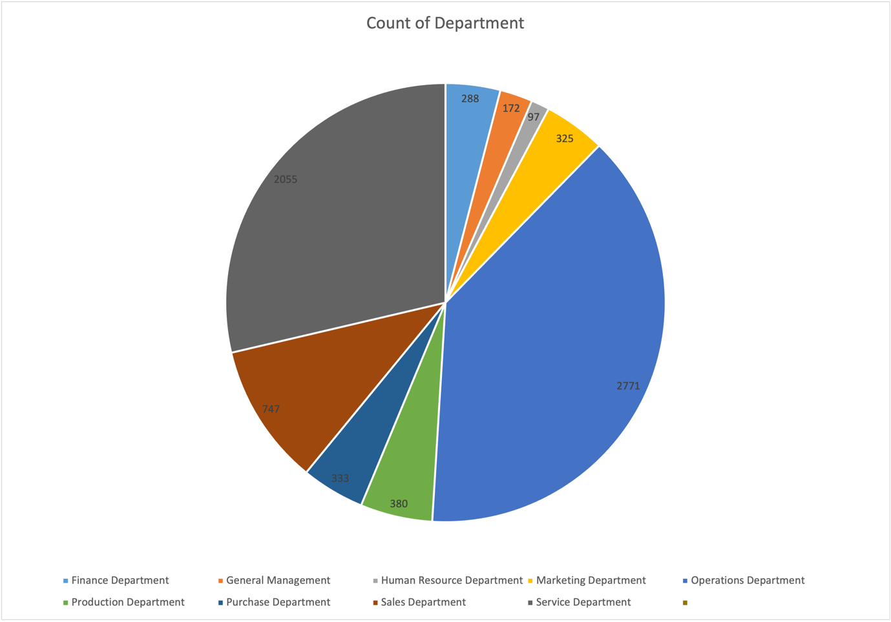

1. **Position Tier Analysis:** Different positions within a company often have different tiers or levels.

Ans: To find the answer of the above problem , we need to find the count of each posts in the company.

|  |  |
| --- | --- |
| **Posts** | **Number Of Posts** |
| b9 | 463 |
| c-10 | 232 |
| c5 | 1747 |
| c8 | 320 |
| c9 | 1792 |
| i1 | 222 |
| i4 | 88 |
| i5 | 787 |
| i6 | 527 |
| i7 | 982 |
| m6 | 3 |
| m7 | 1 |
| n10 | 1 |
| n6 | 1 |
| n9 | 1 |

Now we will plot the bar chart to see the data visuals.

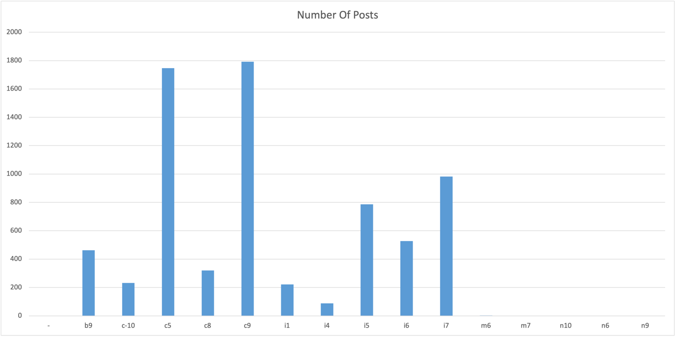

From the above chart we can clearly see that ‘c5’ and ‘c9’ are the posts with highest number of employees.

**Insights:** From the Above queries we can see that the we have focused only 2 departments more and only 3 person are getting salary much higher than the average salary.